A Student’s Guide to:
Using myBlueprint Portfolios to
Self-Assess on Core Competencies

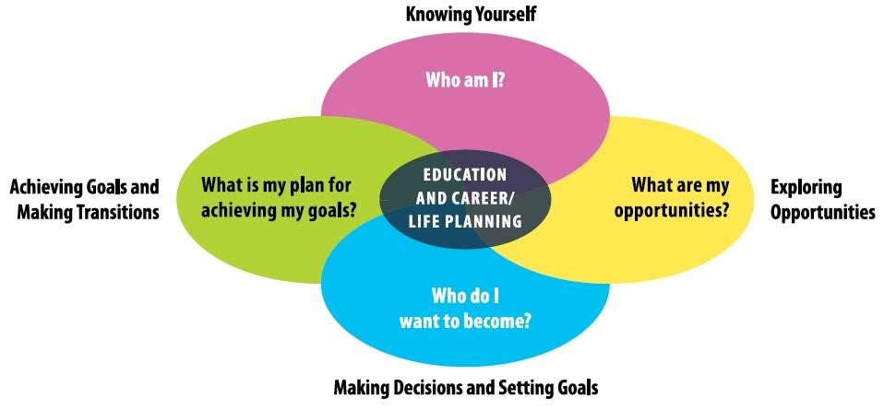



Using myBlueprint to Self–Assess on Core Competencies
Portfolios are a great way to tell your story by purposefully selecting the evidence that you think best demonstrates what you can do. What have you done so far this year that demonstrates your strengths in Communication? Thinking? Personal and Social Responsibility? What are your goals?

GETTING STARTED:

- Visit www.myblueprint.ca, select Log In in the top right corner, and enter your email and password to log in.
  - Forgot your password? Click on “Forgot your password?”
  - Need an account? Select Sign Up at the top right corner.
- Under the Portfolios tab on your homepage, add a portfolio and name it ‘Core Competencies’.
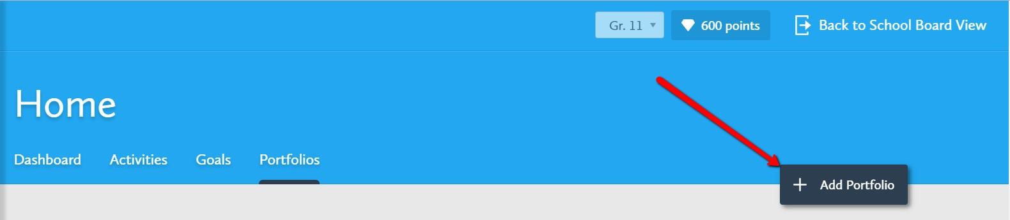

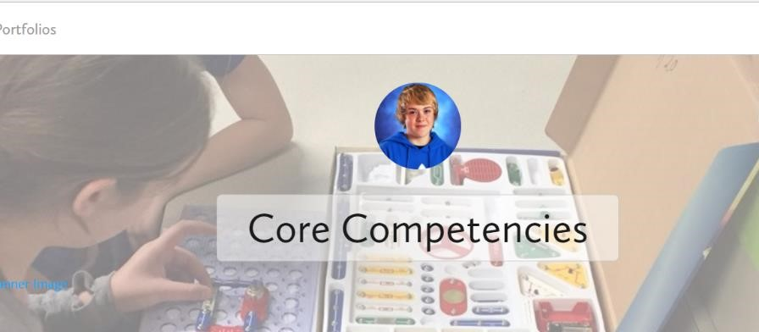
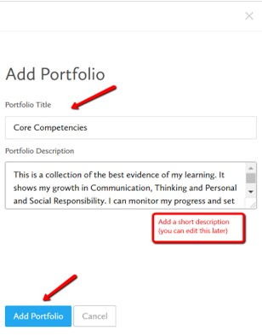

- Click ‘Add Box’ and upload an assignment, a project, a presentation or an event that demonstrates your strength in one of the three core competencies. This could be in the form of a file, a picture, a link or a video.

 The Media box allows you upload pictures, videos, files or links from your device, from Facebook, Instagram, Google Drive or OneDrive.
 The Journal Box will allow you to add these options to a journal entry. (If you don’t have access to the evidence at this point, use this option and add evidence once available).
 The Recent Box will bring up any of the recent activities you have completed in myBlueprint
(survey results, goals, resumes, occupation matches, post-secondary ideas etc.)

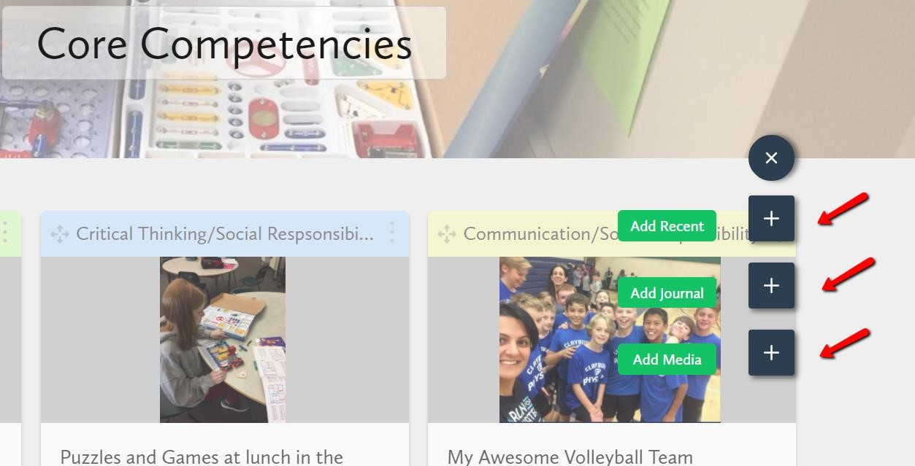

- Title your evidence and write a short description of what you’re sharing. Don’t forget to save!
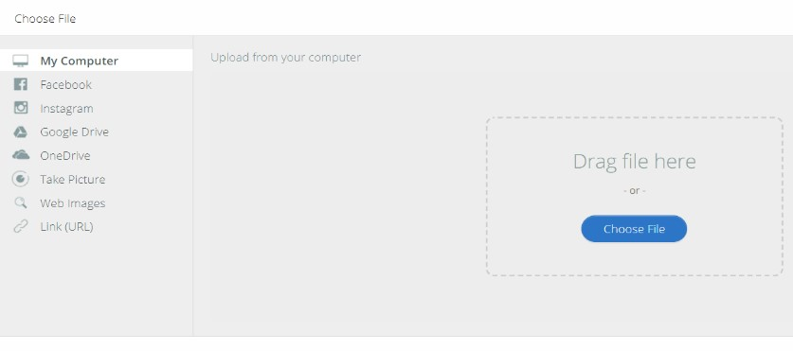
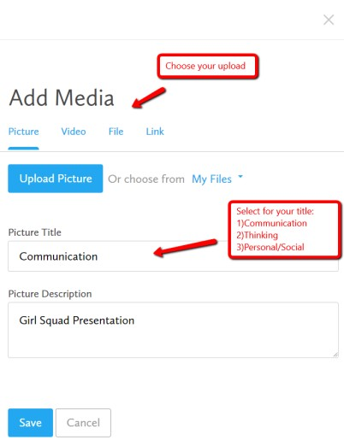

- Add a Reflection. This is the important part! Focus on your strengths and start with “I”. (Check out this How-to Guide again if you’re stuck). These will also help you create achievable goals going forward and monitor your growth over time. Remember, you can keep going back to add multiple reflections.

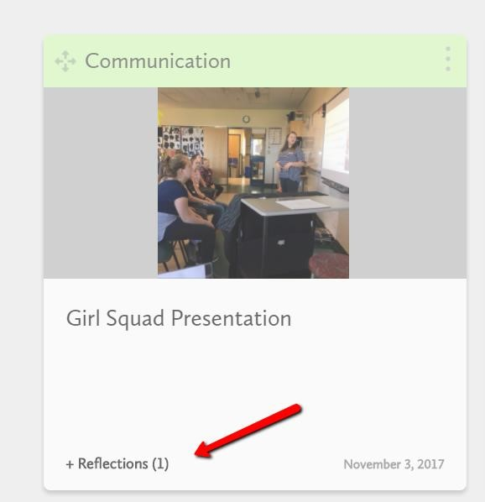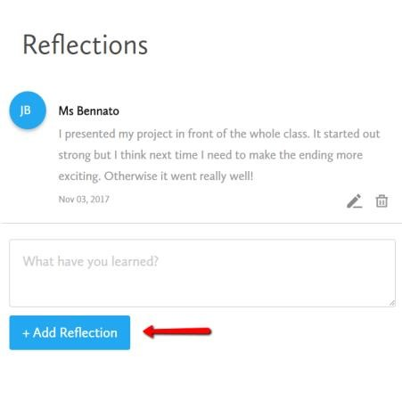

Congratulations! Your Core Competencies Portfolio is underway!

Now that you know how easy it is, repeat steps 3 - 5 to keep adding and reflecting on your amazing evidence of learning!



You can create as many portfolios in myBlueprint as you’d like.
Don’t stop here! Keep telling your story!

