SOCIAL STUDIES 10 – UNIT 6
STUDY GUIDE NO.5a ‘COLD WAR’

NAME: _____________________ TOTAL: /62

INSTRUCTIONS: Please answer each of the following questions to the best of your ability. Use your own words, and NOT those of the textbook or your classmates! Duplicate answers will receive a ‘0’.

1. Please explain the significance of each of the following terms. (10)

United
Nations
(UN)
UN
Security
Council
Democracy
Communism
Cold
War
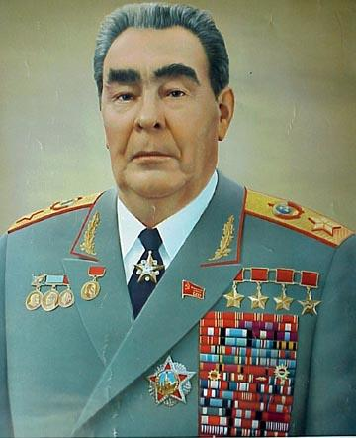
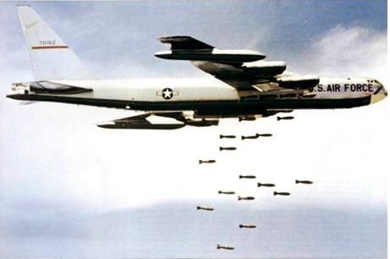
A B-52 Bomber Leonid Brezhnev
2. Please explain the significance of each of the following terms. (16)

Domino
Theory
Containment
Truman
Doctrine

Iron
Curtain
Marshall
Plan
Red Scare
Gouzenko
Affair
Berlin
Airlift &
Blockade

3. Please explain the significance of each of the following terms. (4)

NATO
Warsaw
Pact

4. Please explain the significance of each of the following terms. (12)

Arms Race
Korean
War
Suez Crisis

Cuban
Missile
Crisis
Communist
China
Israel

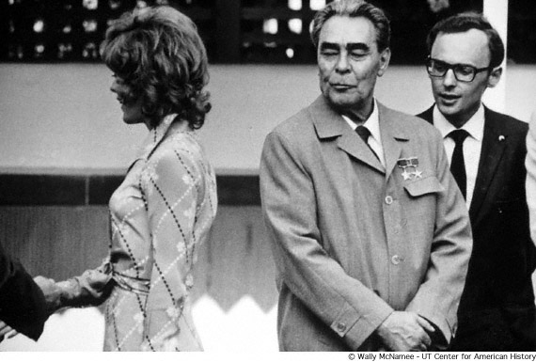
A young Brezhnev on the prowl…
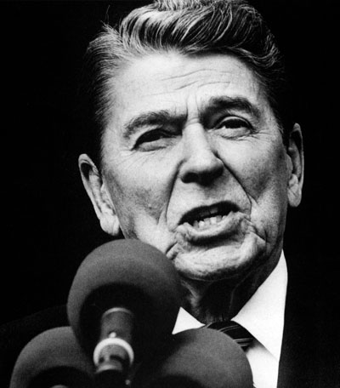
Ronald Regan

5. Please explain the significance of each of the following terms. (12)

Vietnam
War
J.F.K.
Detente

Gorbachev
Glasnost
&
Perestroika
Middle
Power

6. Explain why there was no open conflict between the USA and the USSR during the Cold War? (4)
________________________________________________________________________________________________________________________________________________________________________________________________________________________________________________________________________________________________________________________________________________________________________________________________________________________

7. Why did the Soviet Union collapse? Did the USA ‘win’ the Cold War? (4)
________________________________________________________________________________________________________________________________________________________________________________________________________________________________________________________________________________________________________________________________________________________________________________________________________________________
