SOCIAL STUDIES 10 – UNIT 6
STUDY GUIDE NO.6b ‘COLD WAR in CANADA’

NAME: _____________________ TOTAL: /36

INSTRUCTIONS: Please answer each of the following questions to the best of your ability. Use your own words, and NOT those of the textbook or your classmates! Duplicate answers will receive a ‘0’.

1. Please explain the significance of each of the following terms. (10)

Louis
St.Laurent
John
Diefenbaker
Lester B.
Pearson
Pierre
Elliott
Trudeau
Brian  Mulroney | 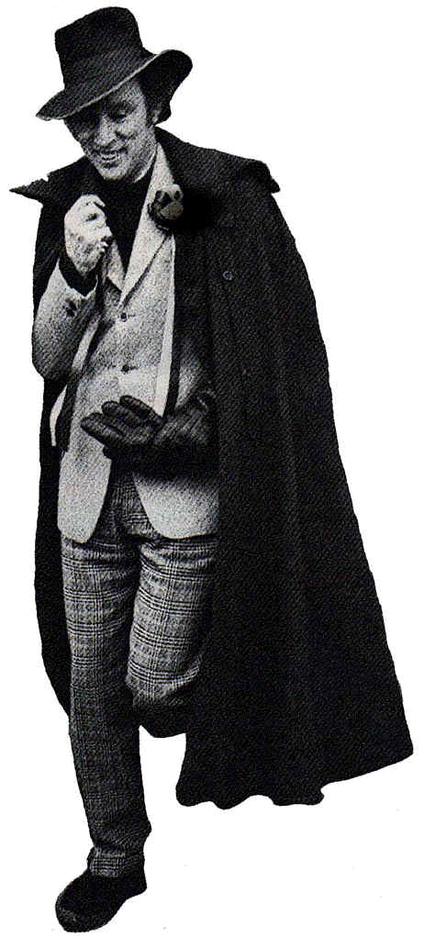
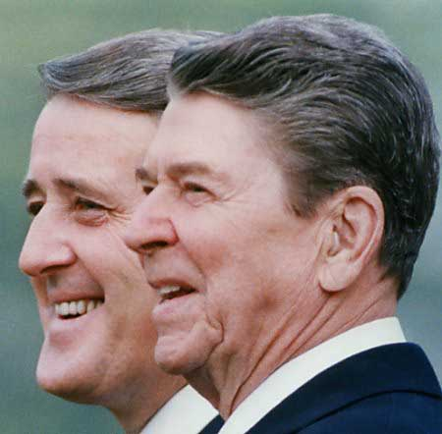
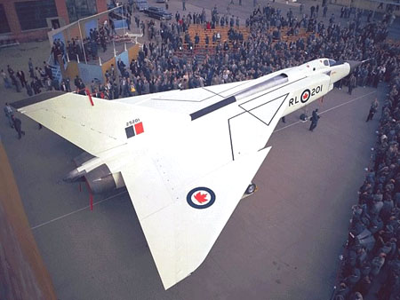

Brian, the Arrow, and a Stylin’ Pierre…

2. Please explain the significance of each of the following terms. (12)

Baby
Boomers
CBC
Suburbs &
Urbanization

Women’s
Liberation
1960’s
Counterculture
Trudeaumania


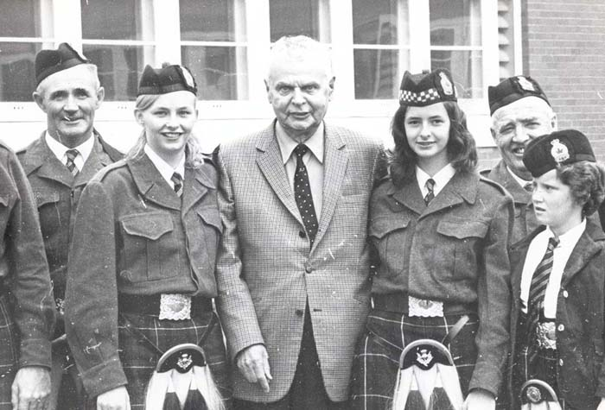

3. Please explain the significance of each of the following terms. (4)

Avro
Arrow
NORAD

4. Please explain the significance of each of the following terms. (10)

OPEC
Crisis
NEP
Flag Debate

Inflation
La
Francophonie

